PROJECT REPORT TEMPLATE

* INTRODUCTION:

* + 1. OVERVIEW:

My project is Travel Trax Tours. I made these project with my team members it is easy to handle and carry accounts.

* + 1. PURPOSE:

It is very useful to handle accounts and proper maintain of all detail to see business result final we achieved.

* PROBLEM DEFINITION & DESIGN THINKING:
  1. EMPATHY MAP

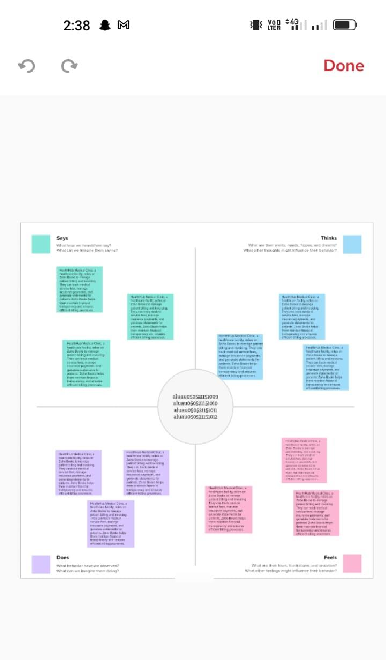

* 1. IDEATION & BRAINSTORMING MAP

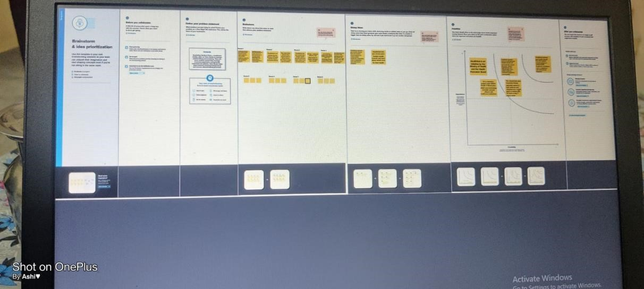

* 1. RESULT:

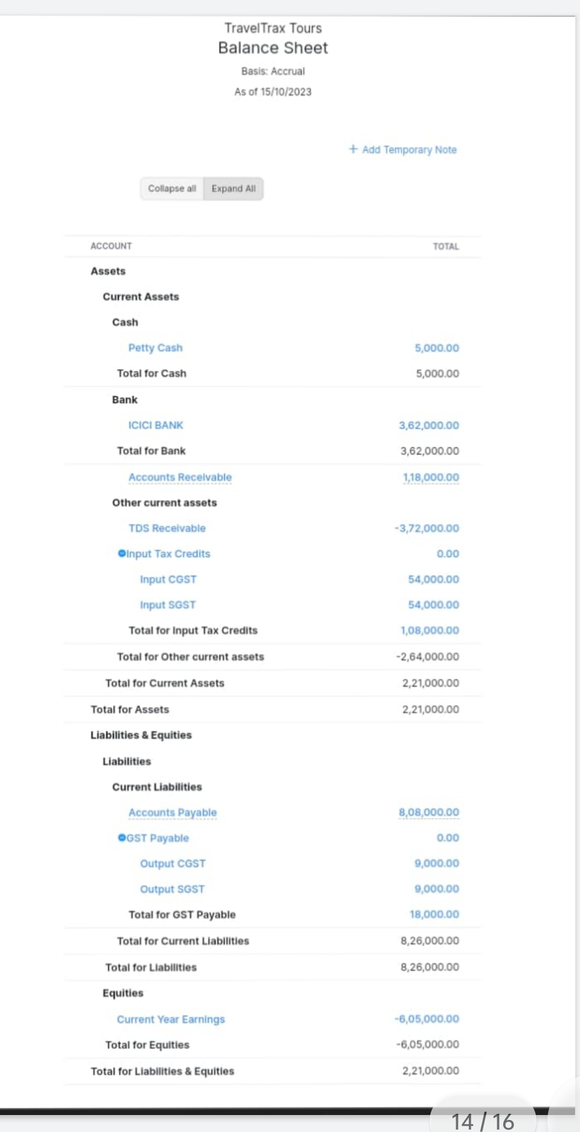

* 1. ADVANTATES & DISADVANTAGES:

It is very useful to refer accounts and handle in proper manner proper output given.

* 1. CONCLUSION:

It improve team efficiency and to get good results.

* 1. FUTURE SCOPE:

It will get good result in future.